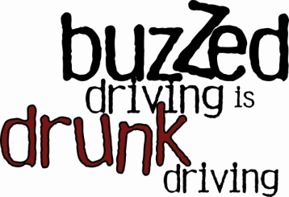
2013 HOLIDAY CAMPAIGN
FACT SHEET
SOCIAL NORMING VERSION

Don’t Turn Your Holiday Into a Tragedy
Buzzed Driving is Drunk Driving

Stay Safe and Drive Sober to Spread the Holiday Cheer

- Drunk driving fatalities occur all year round, but data shows that the holiday season is a particularly dangerous time on the roadways.
- In 2011, 760 people lost their lives as a result of drunk-driving-related crashes during the month of December alone.

- From 2007 to 2011, 14,318 people lost their lives during December. Twenty-nine percent (4,169) died in crashes that involved drivers with blood alcohol concentrations of .08 grams per deciliter or higher.
- That’s why [Local Organization] is joining highway safety partners and law enforcement organizations across the country to remind people during December and throughout the year that Buzzed Driving is Drunk Driving – and to always designate a sober driver.

- Whether you’ve had just one or one too many, hand the keys to a sober driver. Buzzed Driving is Drunk Driving.

- Your decisions can be the difference between life and death. When you drink and drive, you are endangering yourself, your passengers, and those on the road around you.

Remember, Buzzed Driving is Drunk Driving.

- According to the National Highway Traffic Safety Administration, 32,367 people were killed in motor vehicle traffic crashes in 2011, and 31 percent (9,878) of those fatalities occurred in drunk-driving-related crashes.

- Even one drink can increase the risk of a crash while driving. Remember: Buzzed Driving is Drunk Driving.

- Designate a sober driver before the party begins; plan a way to get home safely at the end of the night.

- If you are impaired, call a taxi, phone a sober friend or family member, use public transportation or call your local free ride program. [insert your local sober ride program specifics here].

- Be responsible. If someone you know is drinking, do not let that person get behind the wheel.

- If you see an impaired driver on the road, contact law enforcement. Your actions may save someone’s life, and inaction could cost a life.

- Drunk driving can result in arrest, loss of driving privileges, higher insurance rates, lost time at work, court costs, fines, and attorney’s fees, and many other unwanted consequences.

- For more information on Buzzed Driving is Drunk Driving, please visit www.TrafficSafetyMarketing.gov.
9904a-090513-v1

